PROBLEM STATEMENT
In a city with N landmarks, numbered from 1 to N, there are M one-way roads connecting some of these landmarks. No route forms a loop (i.e., the roads do not create cycles).A group of tourists wishes to travel from Landmark 1 to landmark N, and they are curious about how many unique routes they can take. Your task is to help them by calculating the number of distinct paths from landmark 1 to landmark N.Since the result might be very large, return the answer modulo 109 + 7.
Note: The given graph formed by landmarks and roads is guaranteed to be a DAG.

INPUT FORMAT
The first line of the input contains two space-seperated integers n and m representing the number of landmarks and the number of one-way roads in the city, respectively.Each of the next m lines contains the description of the one-way roads. The new line contains two space-seperated integers u and v, denoting that there is a one-way road from landmark u to v.

OUTPUT FORMAT
Print a single integer represenitng the number of paths from landmark 1 to landmark n modulo 109 + 7.

CONSTRAINTS
1 <= N <= 10^3
0 <= M <= N*(N-1)/2
1 <= u, v <= N

SAMPLE TESTCASE 0
Testcase Input
5 8
1 2
1 4
1 5
2 3
2 4
2 5
3 4
4 5
Testcase Output
5
Explanation
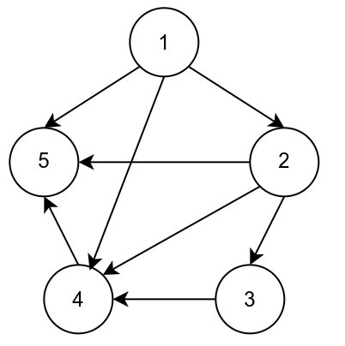

From the given graph, we can see that there are five paths from 1 to 5:
• 1->2->3->4->5
• 1->2->4->5
• 1->2->5
• 1->4->5
• 1->5

SAMPLE TESTCASE 1
Testcase Input
4 4
1 2
2 4
1 3
3 4
Testcase Output
2
Explanation
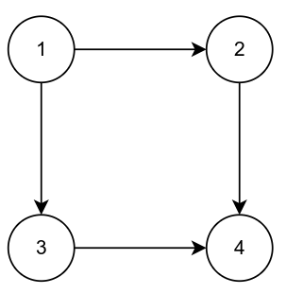
From the given graph, we can observe that there are two paths from 1 to 4:
• 1->2->4
• 1->3->4

